**NOMBRE: FECHA: SID#:**

**Talking Triangles**

**Yo (I) = (-o) Tú (You) = (-as/-es)**

**___________ ___________**

**Él (He) or Ella (She)**

**= (-a/-e)**

**___________**

**NOMBRE: FECHA: SID#:**

**Talking Triangles**

**Yo (I) = Tú (You – inform.) = (-o) (-as/-es)**

**___________ ___________**

**Él (He) or Ella (She)**

**= (-a/-e)**

**___________**

**NOMBRE: FECHA: SID#:**

**Talking Triangles**

**Yo (I) = Ud. (You – form.) =**

**(-o) (-a/-e)**

**___________ ___________**

**Él (He) or Ella (She)**

**= (-a/-e)**

**___________**

**Talking Triangles**

**Yo (I) = (-o) Tú (You – inform.) = (-as/-es)**

**Ud. (You – form.) = (-a/-e)**

**___________ ___________**

**Él (He) or Ella (She)**

**= (-a/-e)**

**___________**

**NOMBRE: FECHA: SID#:**

**Talking Triangles**

**Nosotros (We) = Ustedes (You – pl./form.) =   
 (-amos/-emos/-imos) (-an/-en)**

**___________ ___________**

**Ellos (They – masc.) or Ellas (They – fem.)**

**= (-an/-en)**

**___________**

**NOMBRE: FECHA: SID#:**

**Talking Triangles**

**Nosotros (We) = Vosotros (You – pl./inform.) =   
 (-amos/-emos/-imos) (-áis/-éis/-ís)**

**___________ ___________**

**Ellos (They – masc.) or Ellas (They – fem.)**

**= (-an/-en)**

**___________**

**NOMBRE: FECHA: SID#:**

**Talking Triangles**

**Nosotros (We) = Vosotros (You – pl./inform.) =   
(-amos/-emos/-imos) (-áis/-éis/-ís)**

**Ustedes (You – pl./form.) =**

**(-an/-en)**

**___________ ___________**

**Ellos (They – masc.) or Ellas (They – fem.)**

**= (-an/-en)**

**___________**

**NOMBRE: FECHA: SID#:**

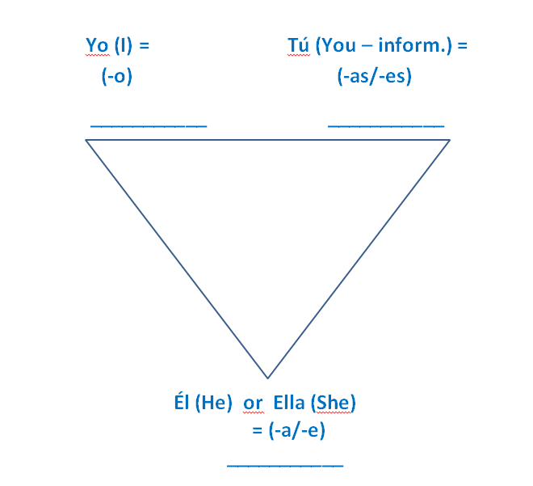**TALKING TRIANGLES - IRREGULARES**



tener: ______________

ir (a): ______________

estar: ______________

ser: ______________

jugar: ______________

querer: ______________

**NOMBRE: FECHA: SID#:**

**TALKING TRIANGLES**



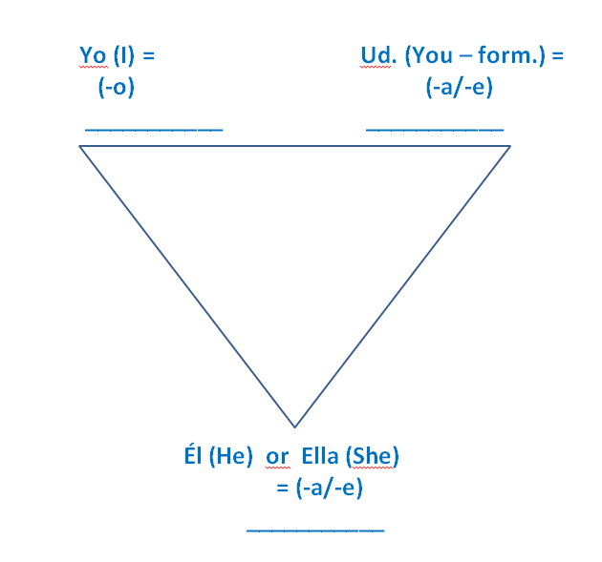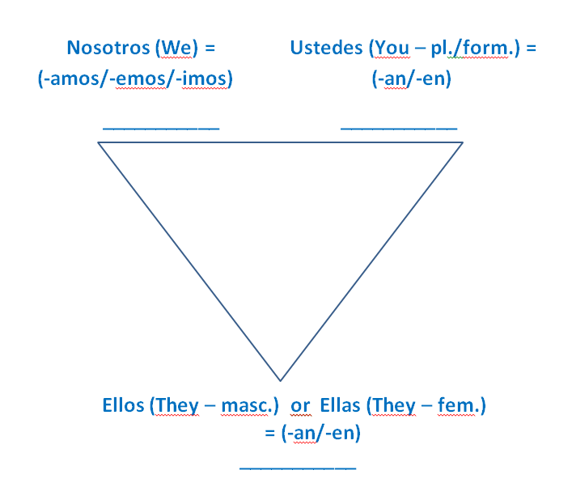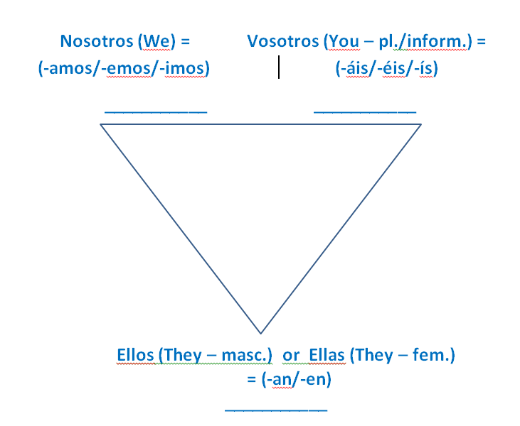





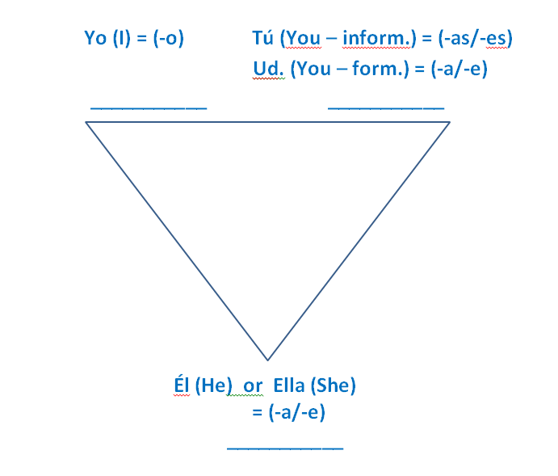

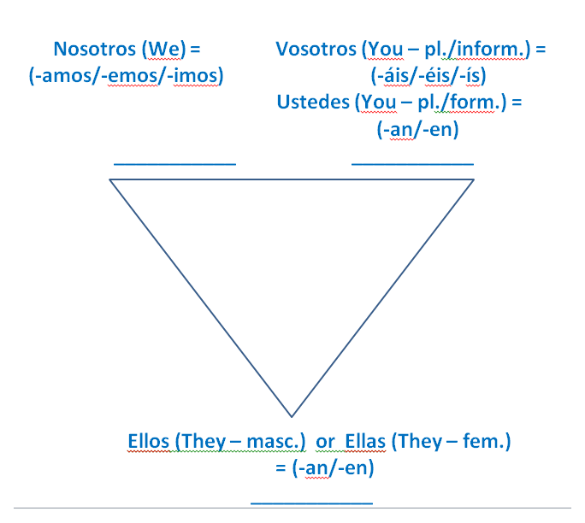

**NOMBRE: FECHA: SID#:**

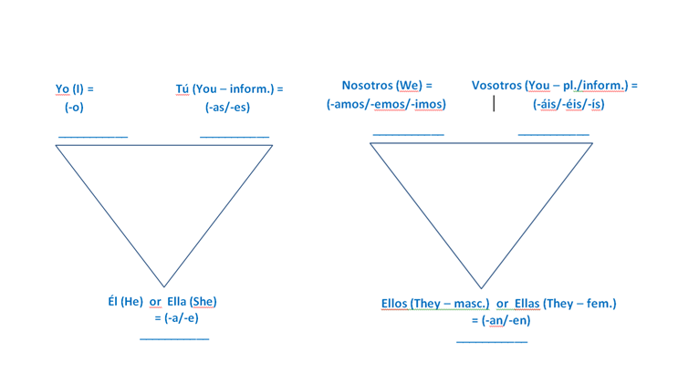**DOUBLE TALKING TRIAN****GLES**